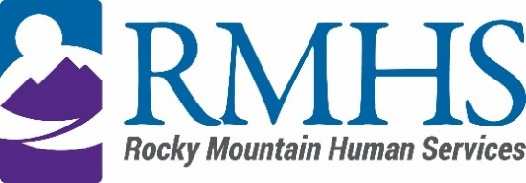

Community Advisory Council Meeting Minutes
March 19, 2024

Members Present: | Maeline Barnstable, Chairperson  Michelle Dumay, Member  and DHS Liaison  Cristine Gomez, Member  Benny Mudliar, Member | Staff: | Georgia Edson, CPO  Dana Johnson, Executive Assistant  Kizzly Blue, Program Manager
Members Absent: |  | Guests: | Michaela Hennig, DHS  Lynn Kuttner, DHS  Brian Bernard, DHS

Maeline Barnstable, Community Advisory Council Chair, called the meeting to order at 3:33 pm via Microsoft Teams.

Introductions
Maeline Barnstable gave a brief welcome and read the mission and goals of the CAC to members, staff, and guests. The guests held a warm icebreaker.

Review and Approval of minutes
The council will review the February minutes at the next meeting.

IDDEAS AD-CO
Michelle Dumay reported an update to the council.

https://denver.prelive.opencities.com/Government/Agencies-Departments-Offices/Agencies-Departments-Offices-Directory/Denver-Human-Services/Events/2021/IDDEAS-Advisory-Council

The council discussed defining parameters of supports offered during the eligibility process including temporary wrap around eligibility services for applicants.

CMA Update
On November 1st RMHS became the CMA (case management agency) for regions 5 and 6, which is Denver and Adams counties.

Individuals who live in those counties or if they choose from a different county are now eligible for RMHS services and support. Georgia provided a timeline of HCPF changes through the implementation of the CMA and the Care and Case Management Data System that is working out the issues of inherited members.

CAC Flier
The council reviewed the recruitment flier that will be posted to the RMHS CAC website and available for members to hand out.

CFDF
Mill Levy Associate Director Abby Grinstead reviewed what Client Family Directed Funds consists of and what populations it serves including adult mill levy support plans, children mill levy supports, family support supplemental, respite and individual requests on Medicaid SLS or DD waivers.

The council discussed ways to maximize the benefit coverage of the waivers before tapping into mill levy funds.

Public Comment
There was no public comment.

Adjournment
The meeting adjourned at approximately 4:58 pm.

Next Meeting
The next Community Advisory Council meeting will be held April 16, 2024 via Microsoft Teams.

