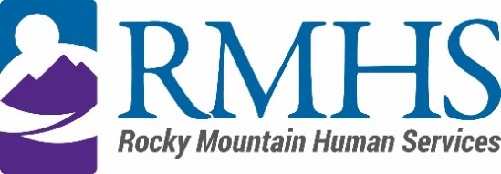

Community Advisory Council Meeting Minutes
April 16, 2024

Members Present: | Maeline Barnstable, Chairperson  Michelle Dumay, Member  and DHS Liaison  Cristine Gomez, Member  Benny Mudliar, Member | Staff: | Georgia Edson, CPO  Dana Johnson, Executive Assistant  Kizzly Blue, Program Manager
Members Absent: |  | Guests: | Michaela Hennig, DHS  Lynn Kuttner, DHS  Brian Bernard, DHS

Maeline Barnstable, Community Advisory Council Chair, called the meeting to order at 3:33 pm via Microsoft Teams.

Introductions
Maeline Barnstable gave a brief welcome and read the mission and goals of the CAC to members, staff, and guests. The guests held a warm icebreaker.

Review and Approval of minutes
The council will review the previous meeting’s minutes at the next meeting.

IDDEAS AD-CO
Michelle Dumay reported an update to the council.

https://denver.prelive.opencities.com/Government/Agencies-Departments-Offices/Agencies-Departments-Offices-Directory/Denver-Human-Services/Events/2021/IDDEAS-Advisory-Council

Recruitment Flier
RMHS’ Communications and Outreach department updated the style, format and language to bring voices of new members who have no experience within the system and its complex jargon. The council discussed ways to make the flier more inclusive and representative of who we serve and the goals of the council.
Public Comment
There was no public comment.

CFDF
Mill Levy Associate Director Abby Grinstead reviewed the Children and Family Directed Funds via DHS. Monetary focuses include Indvidual requests, sustainability and identified functional values. The council discussed having a rubric for decision making for kids and families who need special support and resources beyond schools or medical systems.

Adjournment
The meeting adjourned at approximately 4:58 pm.

Next Meeting
The next Community Advisory Council meeting will be held May 21, 2024 via Microsoft Teams.

