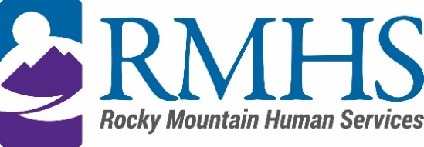

Community Advisory Council Meeting Minutes
June 18, 2024

Members Present: | Maeline Barnstable, Chairperson  Michelle Dumay, Member  and DHS Liaison  Benny Mudliar, Member | Staff: | Abby Grinstead, Associate Director of Mill Levy  Dana Johnson, Executive Assistant  Emily Mowrer, Program Manager  Kizzly Blue, Program Manager
Members Absent: | Cristine Gomez, Member | Guests:

Maeline Barnstable, Community Advisory Council Chair, called the meeting to order at 3:33 pm via Microsoft Teams.

Introductions
Maeline Barnstable gave a brief welcome and read the mission and goals of the CAC to members, staff, and guests. The guests held a warm icebreaker.

Review and Approval of minutes
The council reviewed the February, March and April minutes. Michelle motioned to approve, Benny seconded and they were approved.

IDDEAS AD-CO
Michelle Dumay reported an update to the council.

https://denver.prelive.opencities.com/Government/Agencies-Departments-Offices/Agencies-Departments-Offices-Directory/Denver-Human-Services/Events/2021/IDDEAS-Advisory-Council

Recruitment
The members discussed how they want to review and select the applicants and preferred next steps including a small interview with the hopes to recommend applicants at the next board meeting. The council will move the conversation offline to determine an ideal rubric to create a standardization across recruitment.

Public Comment
There was no public comment.

Individual Requests
The council reviewed expected short term supports, long term supports ad what is appropriate vs denied and number of requests in a calendar year. The council was asked to review the list of supports and determine if the values and justifications are acceptable.

CAC announcements
Benny will start teaching CNA classes; interested participants please click on:
https://www.ccd.edu

RMHS Updates
New website is up and running. Please provide feedback as a parent and user.

Adjournment
The meeting adjourned at approximately 5:30 pm.

Next Meeting
The next Community Advisory Council meeting will be held August 20, 2024 via Microsoft Teams.

