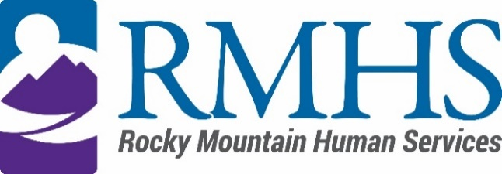

Community Advisory Council Meeting
June 18, 2024

Agenda
The June meeting will be accessible online only. You are invited to attend using the information listed below.
Click here to join the meeting
+1 720-372-0556,783835096# United States, Denver
Phone Conference ID: 783 835 096#
The Mission of the Community Advisory Council is to make informed recommendations that reflect transparency and drive transformation of the culture and community to be inclusive of people of all abilities and backgrounds.
Community Advisory Council Goals:
- Identify and forward recommendations that encourage and expand children and adults' abilities and gifts.
- Identify and recruit diverse membership (social and economic, racial or ethnic, disability, gender, sexual orientation).
- Identify the values and priorities that guide mill levy expenditures.

3:30 pm | Welcome |  | Introductions & Ice Breaker
3:40 pm | March and April Minutes |  | Maeline Barnstable
3:45 pm
  IDDEAS Advisory Council Update
  Michelle Dumay
3:55 pm | Recruitment Next Steps |  | All
4:15 pm | Public Comment |  | All
4:20 pm | CFDF-Sustainability |  | Abby Grinstead
5:00 pm | Announcements

To request translation services or any additional accommodations, contact

Dana Johnson

720-467-3538

djohnson@rmhumanservices.org

