
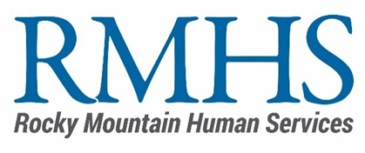
Mill Levy Program
2025 Community Initiative
Minimum Criteria & Scoring Rubric
Minimum Criteria

- Did the applicant meet the minimum criteria to move forward in the review process?
- The applicant submitted the proposal by the deadline.
- The applicant completed the online application.
- The applicant submitted the Line-Item Budget Template to the Mill Levy Inbox.

Objective Review

RMHS reviewers will score each of the following sections on a scale of Zero to Two (0-2) according to the following criteria. The total maximum score is 30 points. RMHS will total the scores of all reviewers and calculate the average score per proposal.

- Does not meet expectation - 0 points
- Meets expectation – 1 point
- Exceeds expectation - 2 points

- Key Focus Areas. The proposal identifies a need, problem, or system gap with a strategy to address it within at least one of the areas of focus.
- Priority Funding Areas. The proposal identifies a need and a strategy to meet that need in one of the 2025 priority funding areas.
- Uniqueness & Innovation. The proposal demonstrates there are no other existing resources meeting the identified need OR offers a unique and/or innovative model to meet an identified need, solve a problem, and/or fill a gap.
- Relevance. The proposal reflects understanding of the supported population and community and considers factors such as demographics, culture, socioeconomic status, etc.
- Effectiveness. The proposal identifies intended outcomes.
- Accountability. The proposal identifies how the project/program will measure progress toward outcomes.
- Accessibility. The project/program demonstrates how it will ensure access for eligible Denver residents.
- Diversity, Equity, & Inclusion. The project/program demonstrates a commitment that can be operationalized to include efforts that move our community towards equity and outcomes where race, ethnicity, disability, immigration status, and identity no longer predict life outcomes.
- Budget & Scope Alignment. The proposal includes a budget that aligns with the scope of work.
- Financial Viability. The proposal demonstrates financial viability by identifying all project/program allowable costs and funding sources.
Scoring Sheet Template
Reviewer Name:
Position:
 | Reviewer Notes/Considerations | Score
Key Focus Areas
2025 Priority Funding Area
Uniqueness & Innovation
Relevance
Effectiveness
Accountability
Accessibility
Diversity, Equity, & Inclusion
Budget & Scope of Work Alignment
Direct Benefit to Denver Eligible Residents
Financial Viability
Total Score

